IREVOLUTION : A DATA -DRIVEN EXPLORATION OF APPLE’S IPHONE IMPACT IN INDIA

**INTRODUCTION :**

**The world has changed as a consequence o increasing use of smartphone, which have improved . communication connected people ,and revolutionized many different business. With its main product ,the iphone ,capturing the markets around the world ,apple inc has emerge as a prominent players among the smartphone maker.**

**VISUALAZATION AND GRAPH :**

EMPATY MAP : 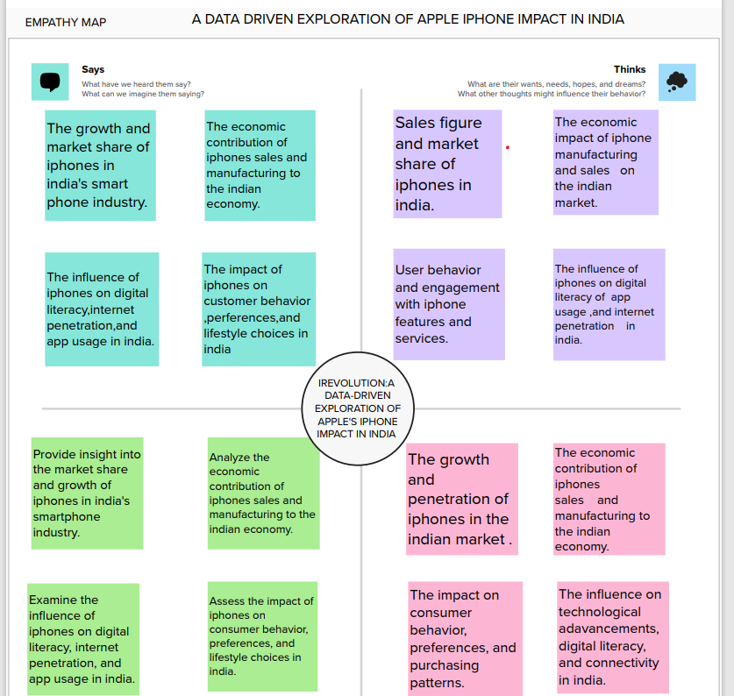

BRAIN STROMING

BRAIN STROMING 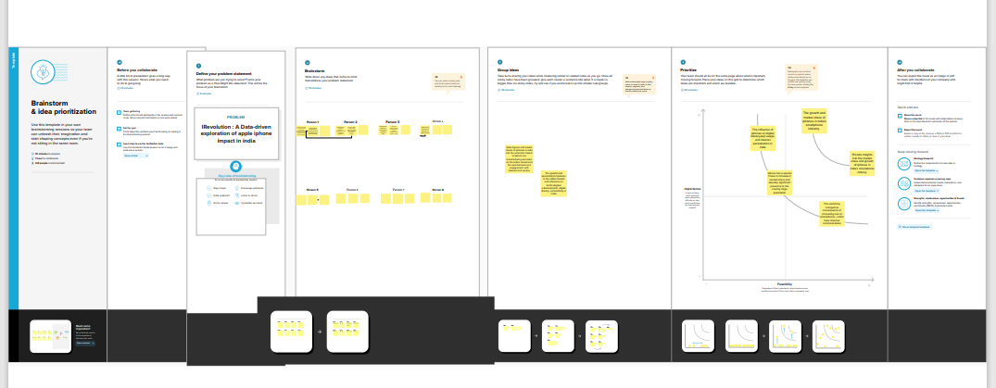

KPI 2 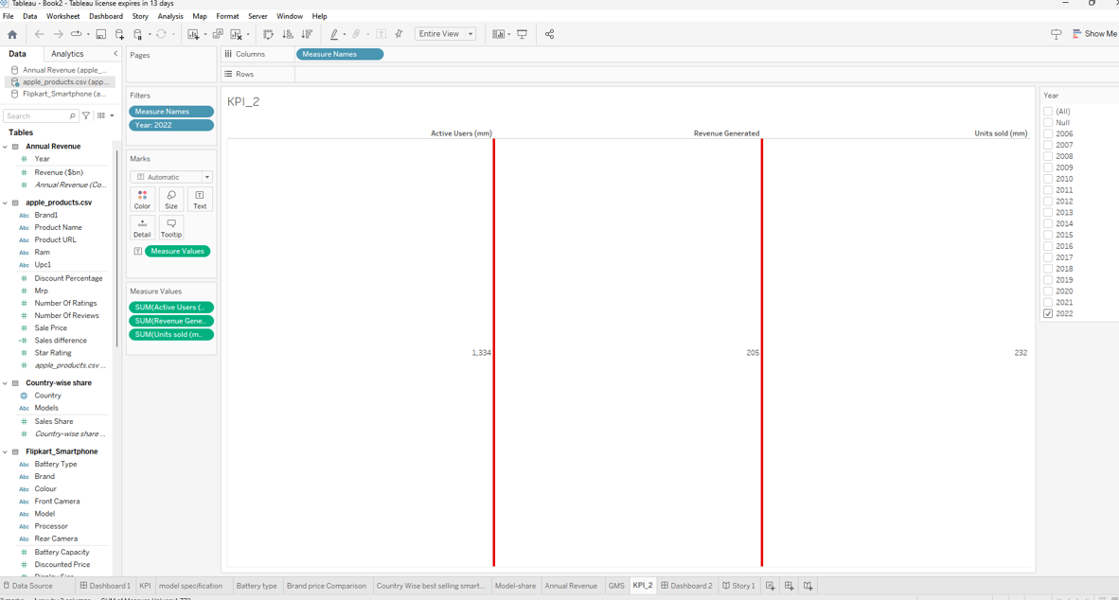

MODEL SPECIFICATION:

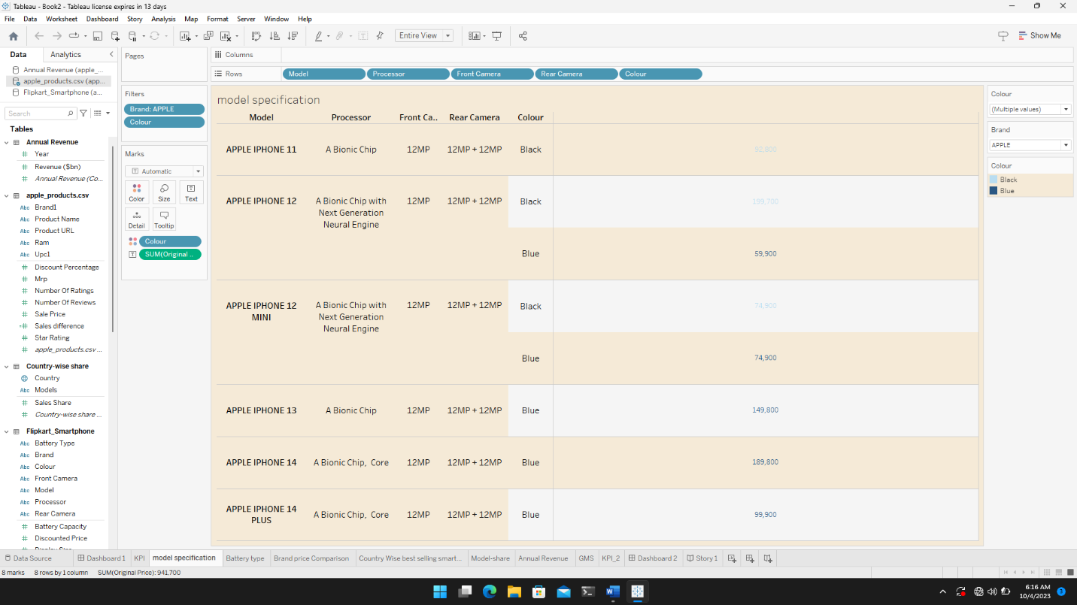

BATTERY TYPE DISTRIBUTION:

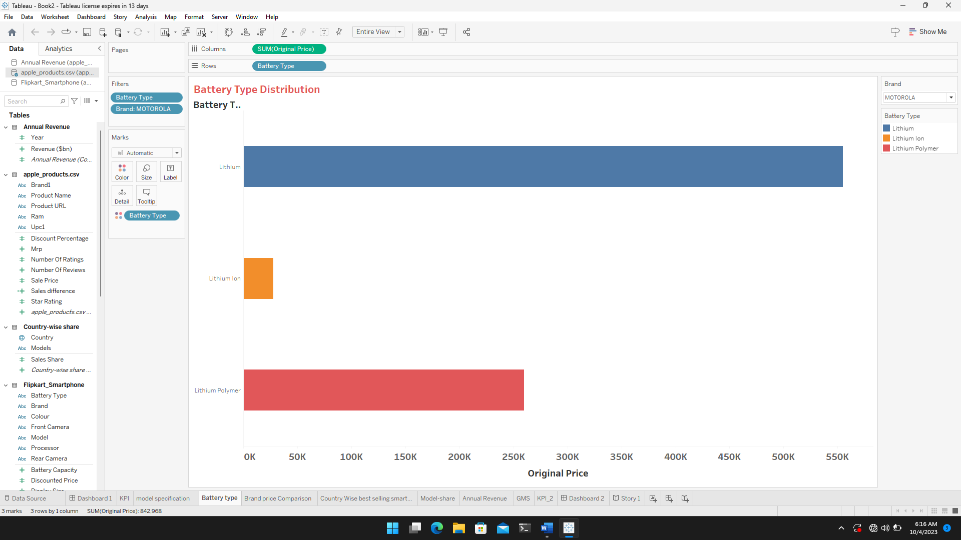

BRAND PRICE COMPARISON :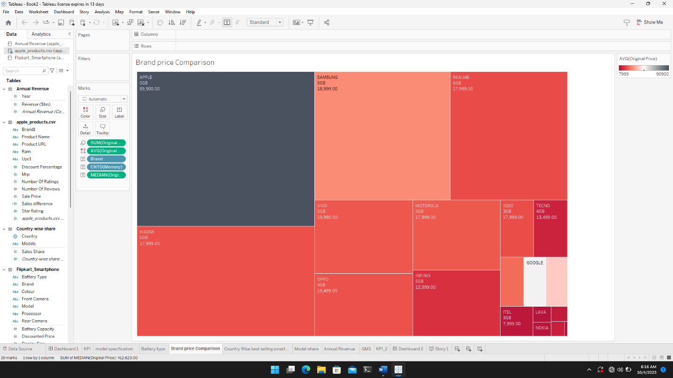

COUNTRY -WISE SELLING : 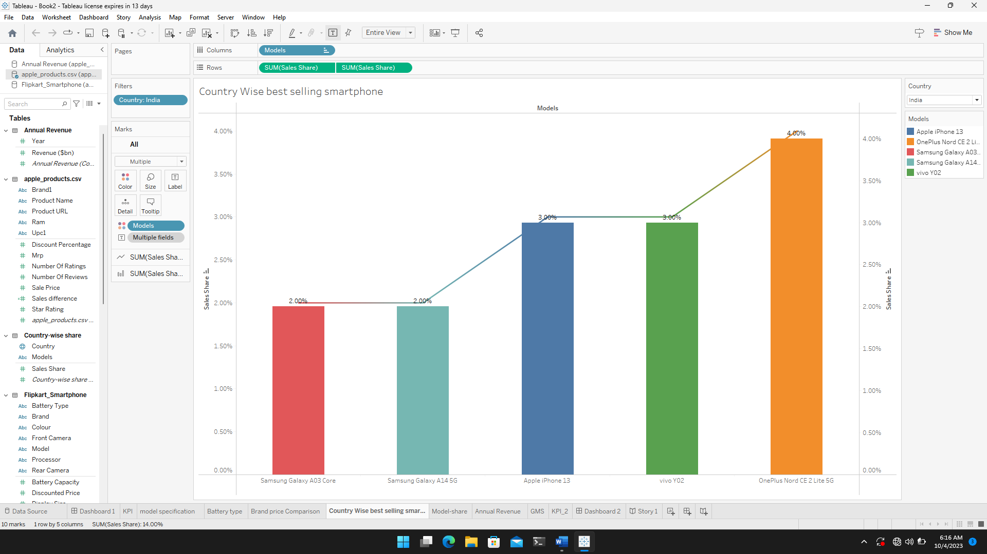

MODEL SHARE: 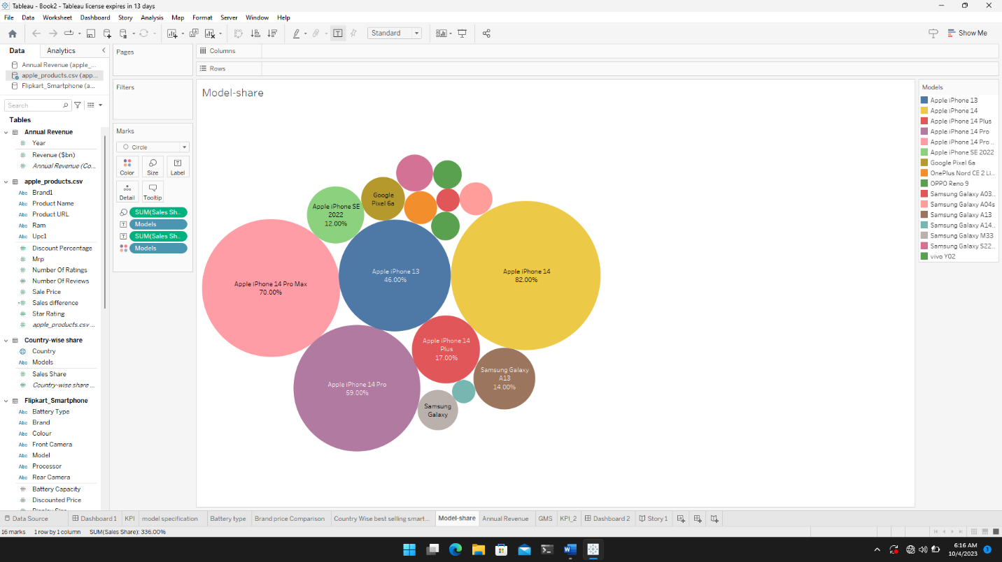

ANNUAL REVENUE : 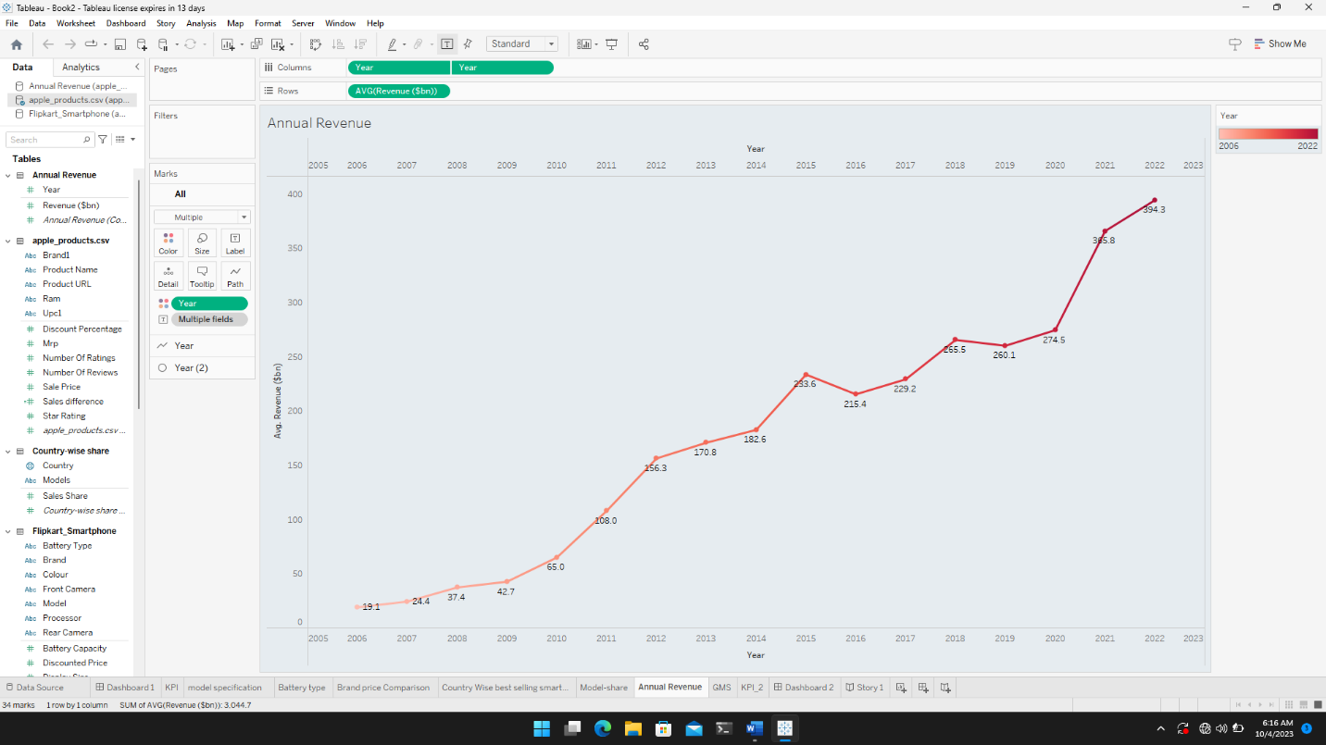

GLOBAL MARKET SHARE: 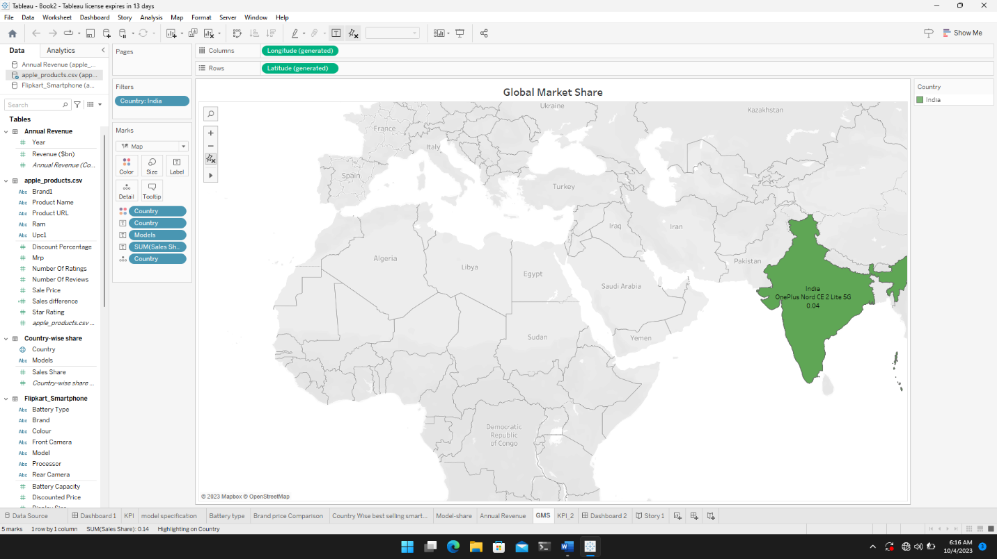

KPI : 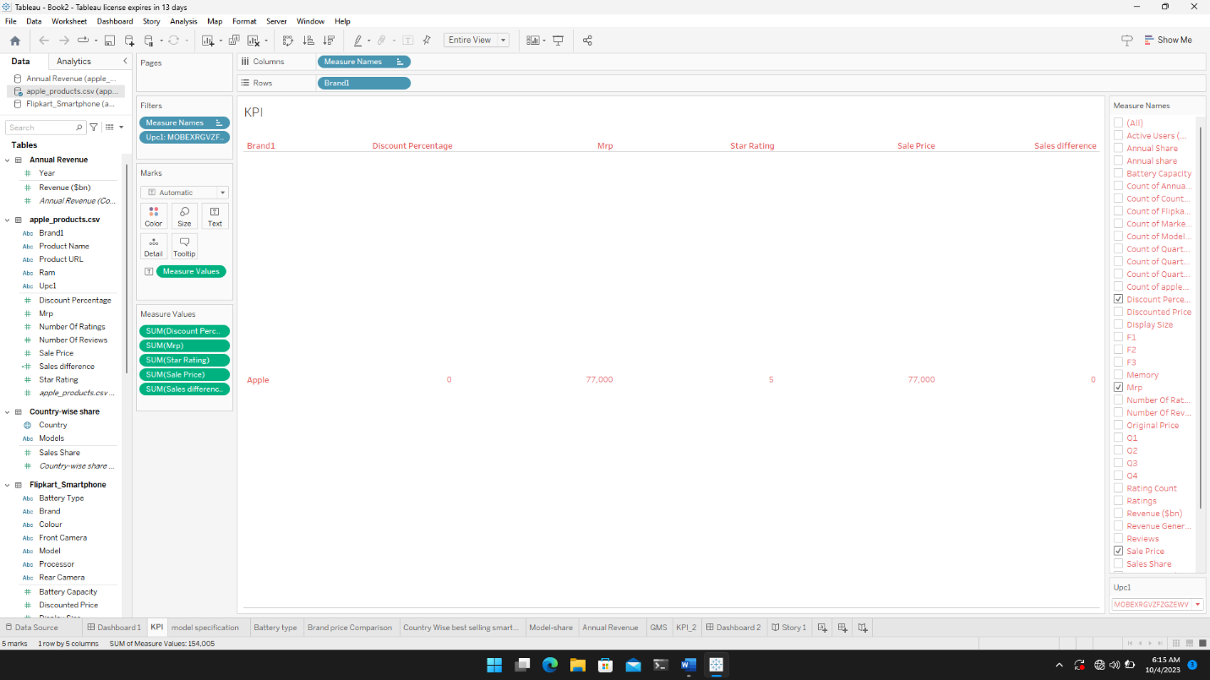

DASH BOARD :

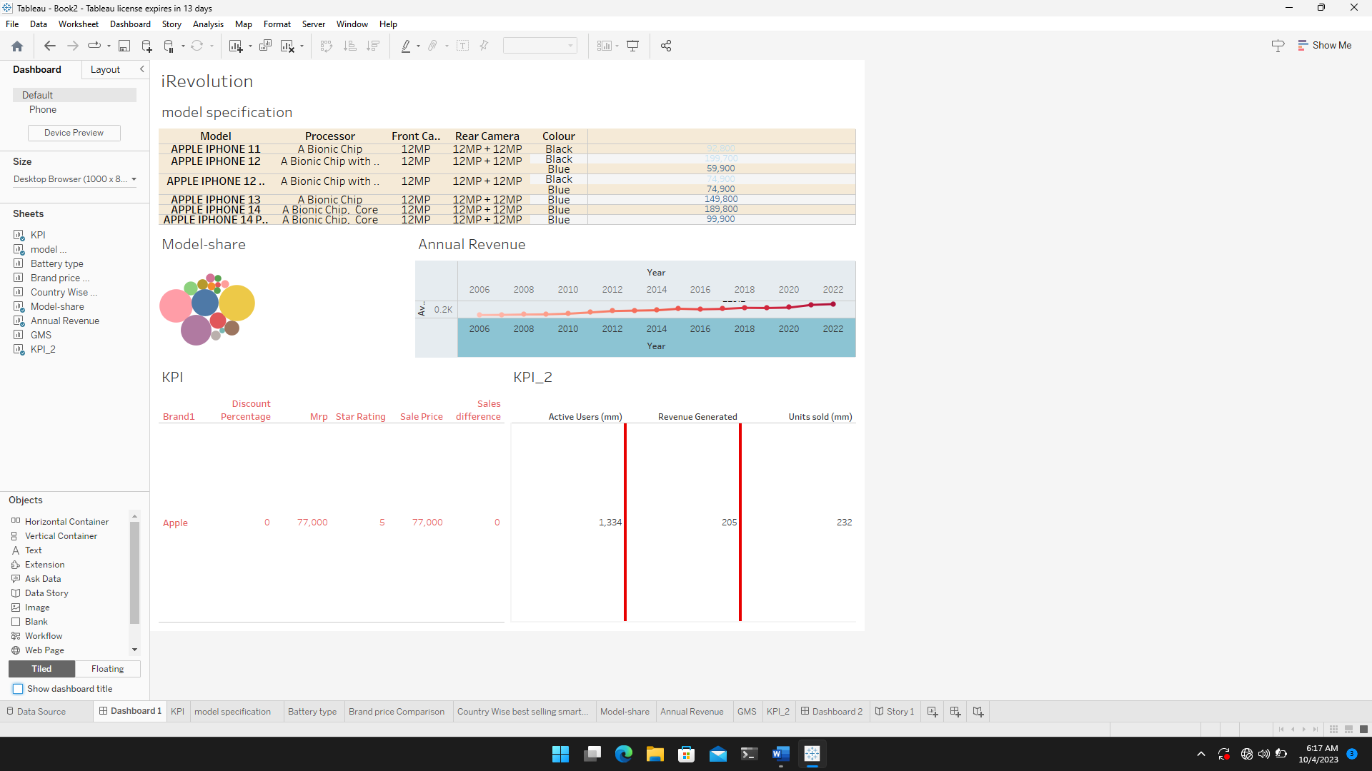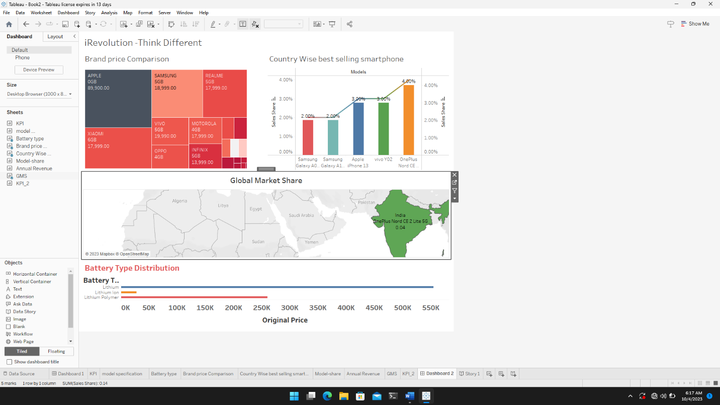

STORY : 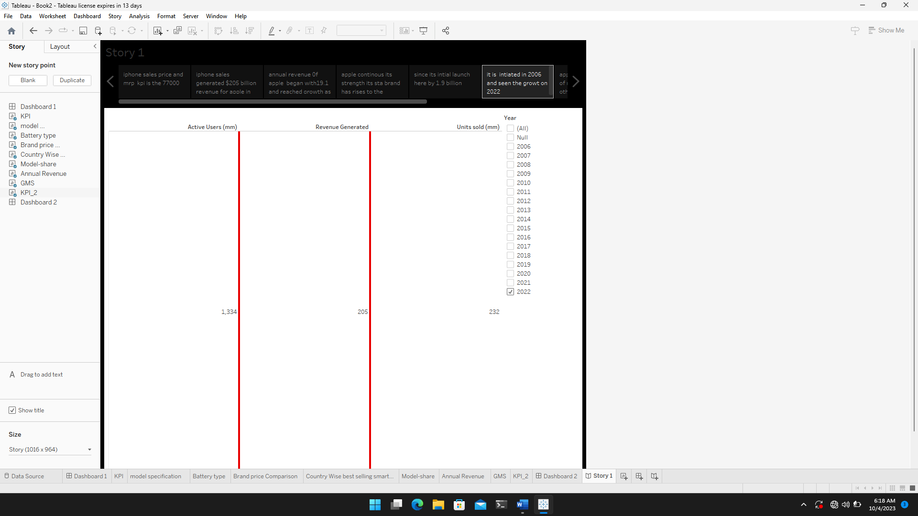

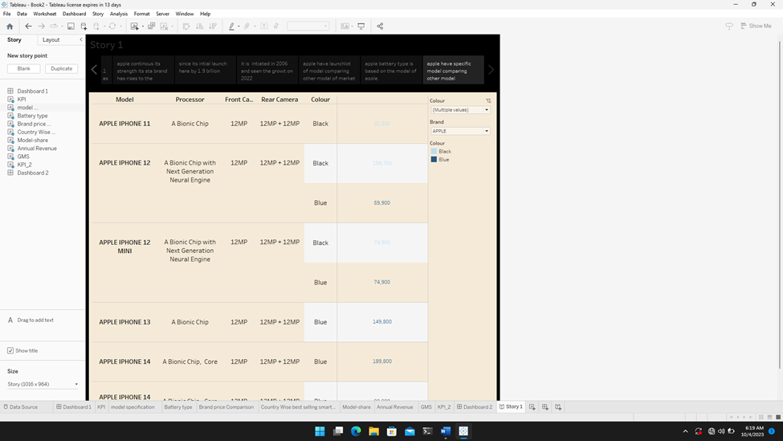

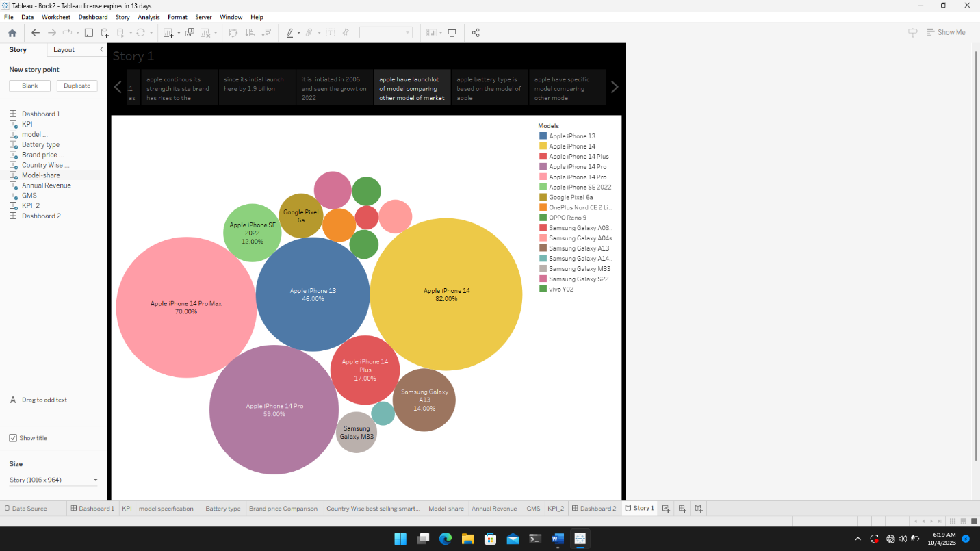

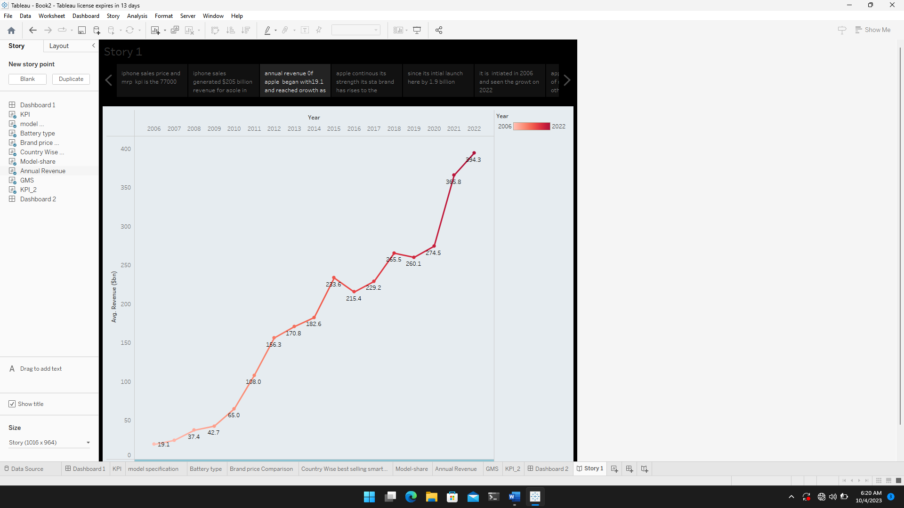

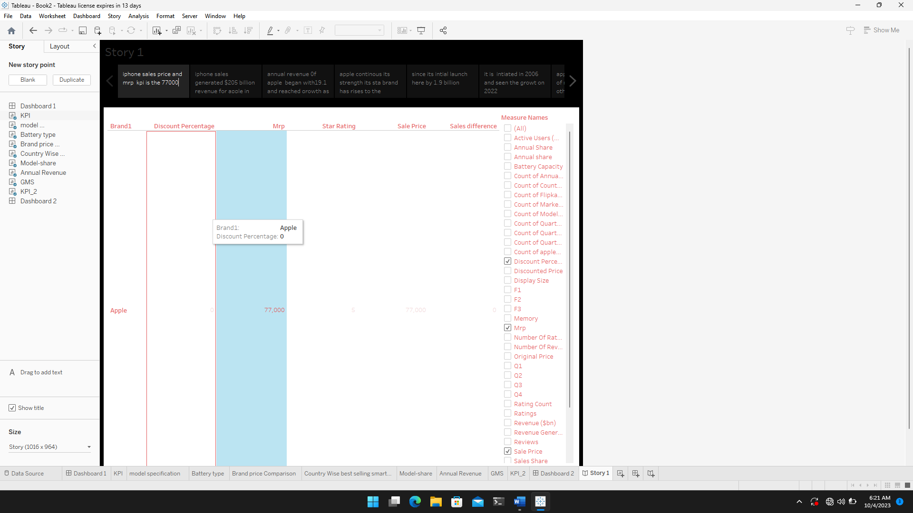

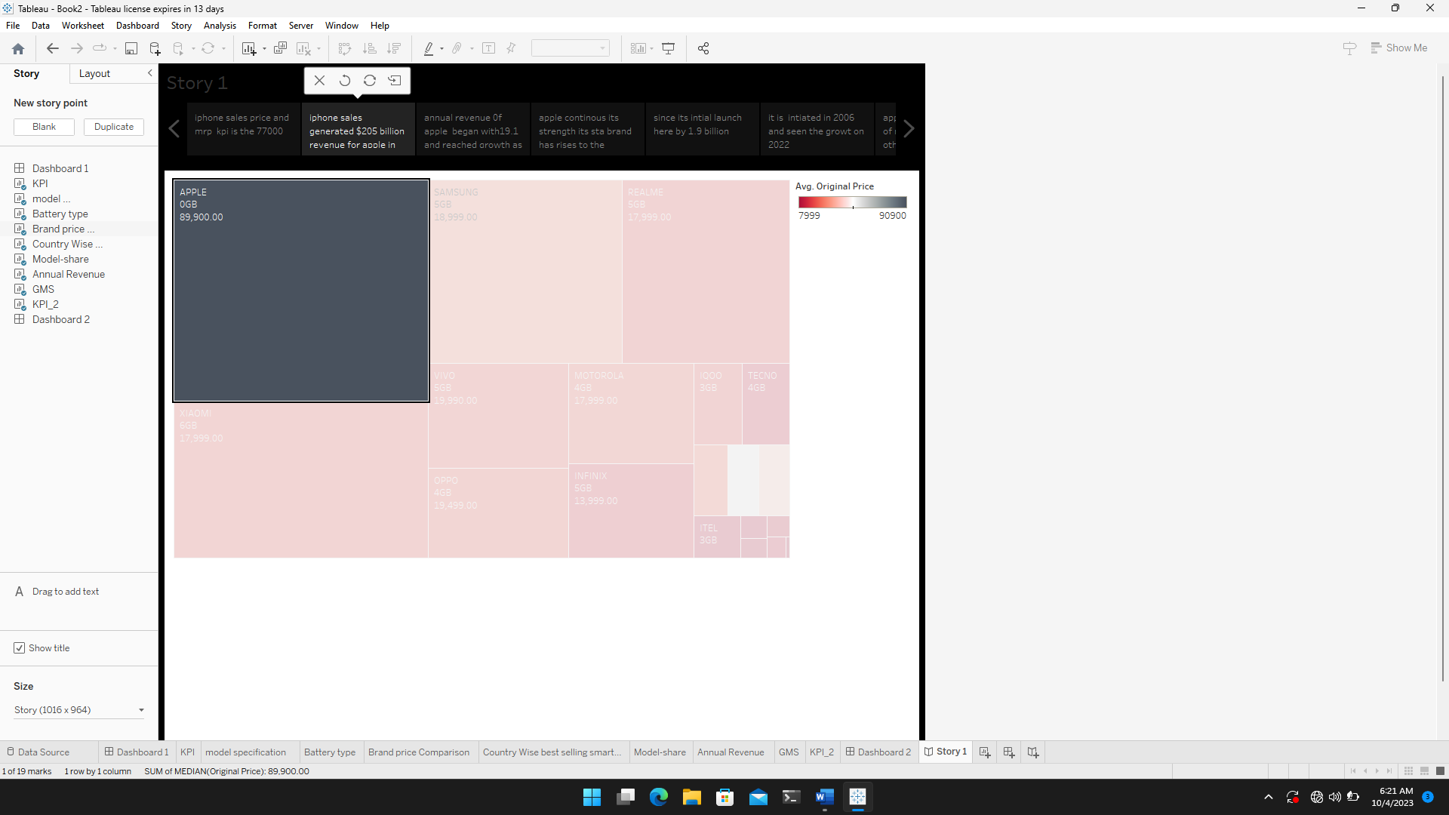

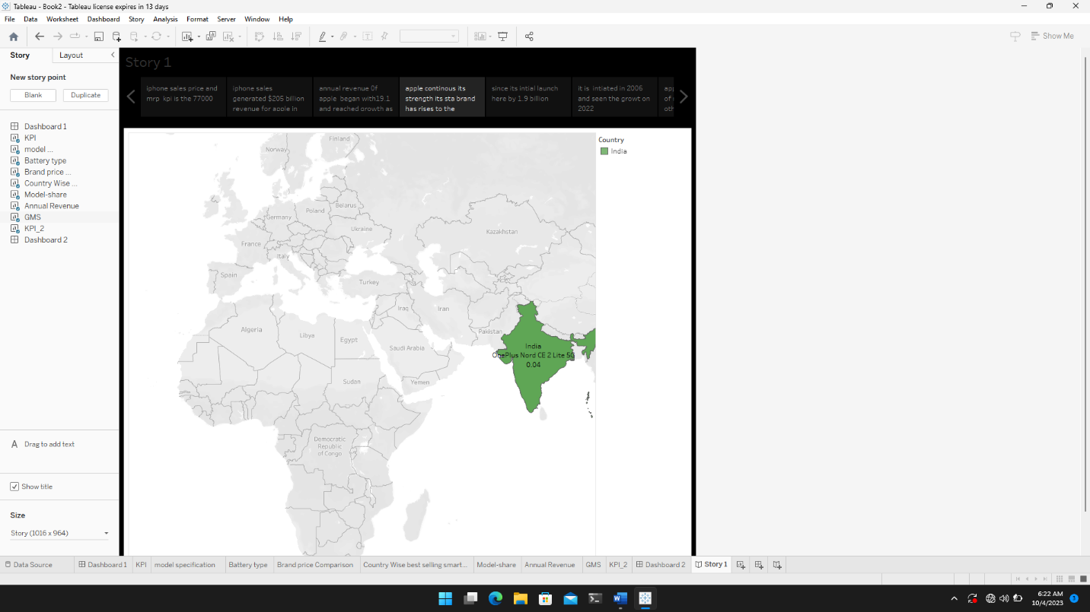

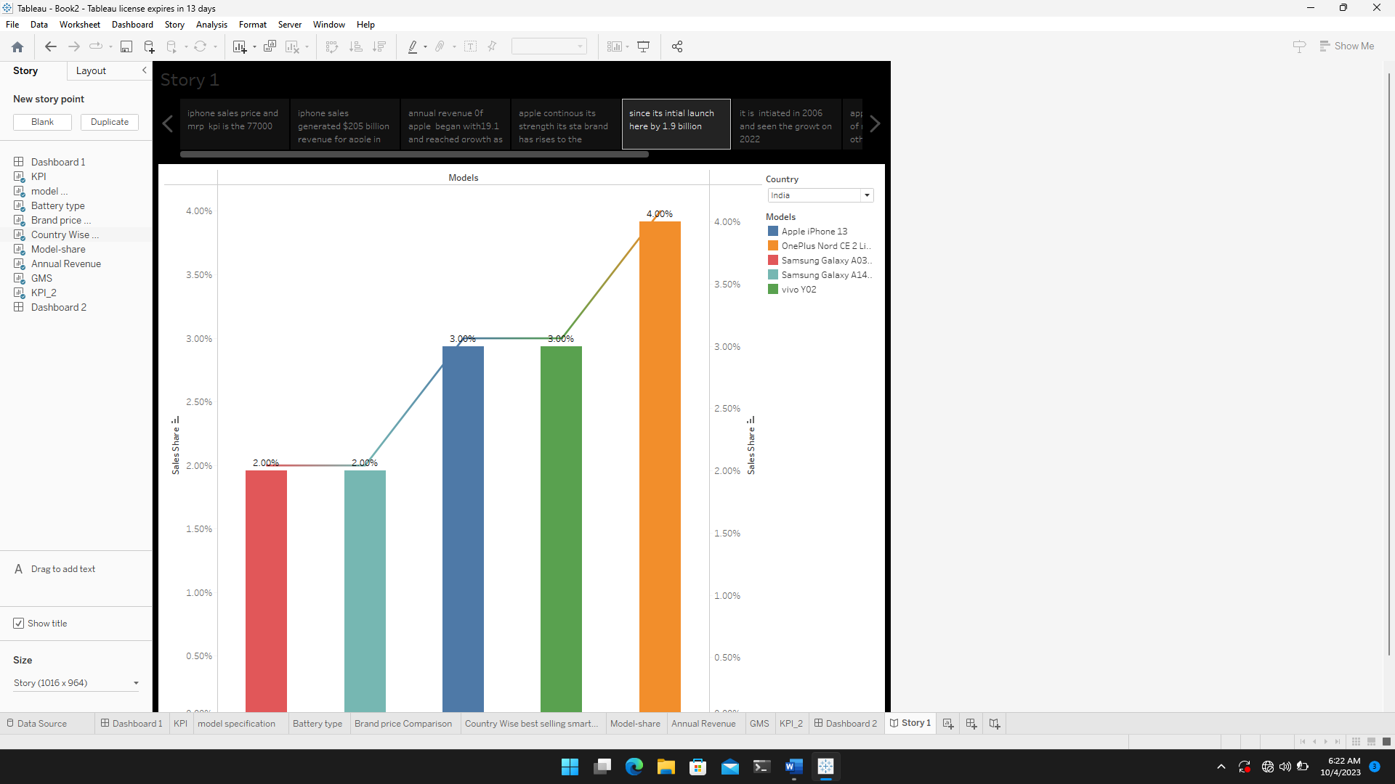

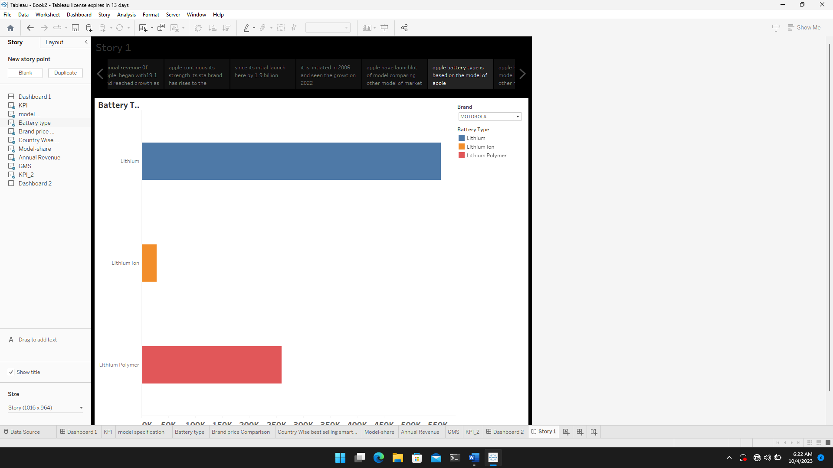

CONCLUSION :

# Apple has special chance to increase its market share and develop a significant present in india .Each new iphone model unveiling generates excitement and anticipation among india buyer